Name: |  | Index Number: |  | Class:


DUNMAN HIGH SCHOOL
PRELIMINARY EXAMINATION
YEAR 6

H1 GEOGRAPHY |  | 8834/01
Monday | 21 September 2026 | 3 hours
Additional material: 1 Insert

READ THESE INSTRUCTIONS FIRST

An answer booklet will be provided with this question paper. You should follow the instructions on the front cover of the answer booklet. If you need additional answer paper ask the invigilator for a continuation booklet.

Answer Question 1 in Section A.
Answer both questions in Section B.
Answer two questions in Section C.

The number of marks is given in brackets [ ] at the end of each question or part question.

This document consists of 4 printed pages and 1 insert

[Turn over

Section A

Cluster 2 Fieldwork

1 | Eight students undertook an investigation into access to heat-relief facilities in Chinatown, Boston City, Massachusetts, USA. These facilities are established and managed by local community organisations. They examined the relationship between heat exposure and access to heat-relief facilities by investigating the hypothesis:  “Residents of Boston Chinatown living in areas of greater heat exposure have better access to heat-relief facilities.”  They selected four residential sites A, B, C and D, within Boston Chinatown. They collected data between 1.00 p.m. and 3.00 p.m. on a weekday in July, during the summer period.  Two students were assigned to each site. At their assigned site, they measured air temperature using a digital thermometer and estimated the percentage of shade cover. Both students then walked separately from their respective sites to the nearest heat-relief facility, and their recorded walking times were added together and divided by two to obtain the mean walking time. They also conducted a questionnaire survey with the first 10 adult respondents at each site, who were available and willing to participate, about their perceived accessibility of heat-relief facilities.  Resource 1 is a map of Boston Chinatown showing Sites A, B, C and D and heat-relief facilities. Resource 2 shows information about the age profile of respondents and Boston Chinatown residents. Resource 3 shows the findings of the investigation at the four sites.

 | (a) | Explain one strength and one weakness in the students’ hypothesis.  Candidates could recognise that the hypothesis is set at an appropriate and manageable spatial scale, as Boston Chinatown is a small area of about 1.2 km² that can feasibly be studied by eight students within two hours. However, they could also note that the term “better access” is vague and not clearly operationalised, as it could refer to proximity, affordability or ease of entry, making it unclear what should be measured to test the hypothesis. | [4]
 | (b) | With reference to Resource 1, explain the strengths and limitations of the students’ choice of the four sites.  Candidates could identify strengths in the site selection, including variation in built environments, some spatial representation across Chinatown, and practical considerations such as proximity to heat-relief and civic/community facilities that support feasible and safer data collection. However, they could also recognise limitations in representativeness, as the sites are concentrated in the southern half of Chinatown, are all relatively close to heat-relief facilities, and may under-represent residents living in denser built-up areas. | [4]
 | (c) | Explain the ethical issues that may arise from the students’ investigation.  Candidates could identify ethical considerations relating to informed consent, voluntary participation, anonymity and confidentiality, ensuring that respondents understand the survey and are free to refuse or withdraw without their personal information being disclosed. They could also recognise the need to minimise disturbance and avoid culturally or racially insensitive questions or comments, particularly those concerning citizenship or ethnicity that may cause discomfort among local residents. | [3]
 | (d) | Explain why the walking time recorded by the students may not be a fully valid measure of residents’ access to heat-relief facilities.  Candidates could identify limitations relating to the representativeness of the walking-time measurements, as two young students may walk faster or use different routes and modes of travel from residents, while the method also assumes that residents use the nearest heat-relief facility. They could also recognise that walking time provides only a narrow measure of access, since actual accessibility may be influenced by factors such as mobility needs, facility choice, awareness, opening hours and capacity. | [4]
 | (e) | Using Resource 3, construct a suitable graph to show the relationship between air temperature and mean walking time at the four sites.  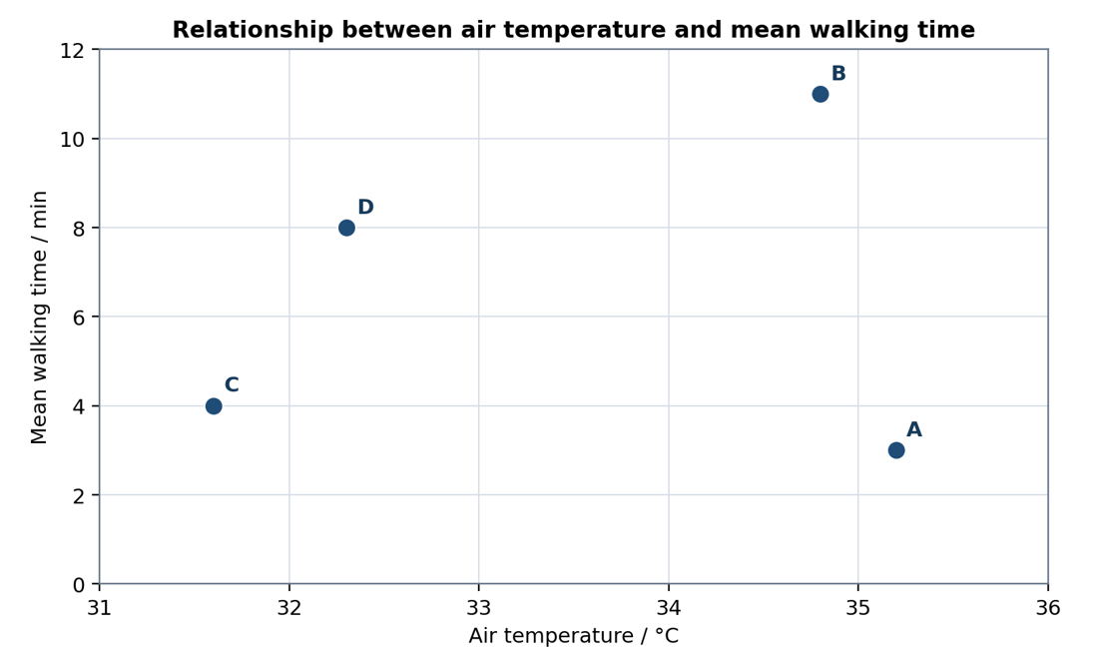 | [5]
 | (f) | The students concluded that residents living in areas of greater heat exposure have better access to heat-relief facilities. Evaluate the validity of their conclusion.  Candidates could assess that the conclusion is only somewhat valid, as Sites A and D provide some support for the proposed relationship, while Sites B and C show that greater heat exposure is not consistently associated with better access to heat-relief facilities. They could evaluate the validity of the methods, noting that outdoor temperature, shade cover and walking time may not accurately represent residents’ actual heat exposure or accessibility, while the respondent sample may also include non-residents or self-selecting participants. They could also identify concerns over accuracy and reliability, including possible thermometer calibration differences, subjective estimates of shade and perceived accessibility, an age-unrepresentative sample, data collection on only one afternoon, and the use of just four sites concentrated in southern Chinatown. | [10]

Section B
Cluster 1 Sustainable Future and Climate Change

Answer both questions.

2 | Resource 4 shows the maximum continental and sea ice cover in the Northern Hemisphere during the Last Glacial Maximum and today. Resource 5 shows the projected percentage change in Gross Domestic Product per capita (GDP per capita) in countries due to climate change. Resource 6 shows a map of countries with ocean pH monitoring equipment.
 | (a) | Using Resource 4, compare the maximum continental and sea ice cover in the Northern Hemisphere during the Last Glacial Maximum with that of today.  Candidates could compare similarities such as the presence of sea ice in the Arctic Ocean and the Greenland ice sheet in both periods. They could also note differences such as the reduction in the number of continental ice sheets from four to one, and the decreased extent of sea ice in the North Atlantic Ocean today. | [4]
 | (b) | Explain the role of human activities in accelerating the warming of the atmosphere through positive feedbacks.  Candidates could explain how human activities such as burning fossil fuels release greenhouse gases that raise atmospheric temperatures. They could then describe how this triggers positive feedbacks such as ice-albedo feedback, water vapour feedback, or permafrost melting, each of which further amplifies warming. | [5]
 | (c) | Using Resource 5, describe the distribution of the projected percentage change in Gross Domestic Product per capita (GDP per capita) as a result of climate change.  Candidates could describe how countries in the low latitudes, particularly across Africa and South America, are projected to experience declines in GDP per capita. They could also note that countries in higher latitudes, especially in Europe and Northern Asia, are projected to experience increases, with the most severe declines of -20 to -30% concentrated in North Africa and the Middle East. | [4]
 | (d) | With reference to Resource 5, explain the distribution of the projected percentage change in Gross Domestic Product per capita (GDP per capita) as a result of climate change.  Candidates could explain how tropical regions face greater GDP declines due to their higher vulnerability to extreme weather events and dependence on climate-sensitive industries such as agriculture and tourism. They could also explain how higher-latitude countries benefit from longer growing seasons and increased Arctic shipping routes, while greater adaptive capacity in wealthier nations helps cushion economic losses. | [5]
 | (e) | With reference to Resource 6, suggest reasons for the uncertainties over the present and future effects of climate change.  Candidates could suggest that the uneven distribution of ocean pH monitoring equipment, concentrated largely along Atlantic coastlines with few sites in the Indian, Pacific, and Southern Oceans, limits the reliability of global data. They could also suggest that incomplete scientific understanding of processes such as cloud formation, combined with the difficulty of predicting future greenhouse gas emissions, further contributes to uncertainty. | [4]

3 | Resource 7 shows the percentage of population living in urban areas. Resource 8 shows the percentage change in size of urban area and population density in selected Indian cities from 2005 to 2020. Resource 9 shows a slum in Delhi, India. Resource 10 shows the percentage of slum houses with selected features before and after redevelopment in Delhi, India.
 | (a) | Using data from Resource 7, describe the trends of the percentage of population living in urban areas.  Candidates could describe how all continents experienced an increase in urban population percentage, with Africa recording the greatest rise from 47% in 1950 to a projected 85% in 2100. They could also note differences in magnitude, such as Europe having the smallest increase of around 13%, and shifts in ranking, with Asia projected to become the most urbanised continent by 2100. | [5]
 | (b) | Using Resource 8, compare the percentage change in the size of urban area and population density across Indian cities from 2005 to 2020.  Candidates could note that all cities experienced an increase in urban area size, ranging from 18% in Nagpur to 160% in Coimbatore, while most also saw increases in population density. They could also highlight that most cities saw larger increases in urban area size than in population density, with Mumbai being the exception as the only city to record a decline in population density. | [3]
 | (c) | Explain how cities with a large demand on the environment contribute to contemporary climate change.  Candidates could explain how large-scale industrialisation and high energy consumption in such cities leads to greater burning of fossil fuels, increasing greenhouse gas emissions. They could also explain how deforestation for urban expansion reduces carbon absorption, while decomposing waste in landfills releases methane, further contributing to climate change. | [4]
 | (d) | Using Resource 9, explain how the characteristics of the slum increases residents’ vulnerability to climate change.  Candidates could explain how the proximity of slum housing to the river exposes residents to a greater risk of flooding during intense rainfall events intensified by climate change. They could also explain how poor building quality, such as metal roofs with little ventilation and close-packed housing, traps heat and increases residents' susceptibility to heat-related illnesses as temperatures rise. | [5]
 | (e) | Using Resource 10, explain how slum redevelopment has improved the social well-being of slum residents in Delhi.  Candidates could explain how increased access to sanitation facilities at home reduces disease transmission and improves hygiene, while also providing greater privacy and dignity for residents. They could also explain how piped water at home ensures a more stable and clean water supply, reducing time spent collecting water, and how cooking in a separate kitchen improves respiratory health and reduces overcrowding in living spaces. | [5]

Section C

Cluster 1 Sustainable Future and Climate Change

Answer two questions.

4 | ‘Cities with high urbanisation rates and rapid population growth face greater challenges in progressing towards sustainable urban development.’  Evaluate this statement.  Indicative Content  Progress towards Sustainable Urban Development (SUD) is all encompassing and refers to progress made in the three key areas: economic vitality and environmental integrity of the city, whilst considering the social well-being of the residents. For an evaluative response, candidates can contrast the challenges faced by cities with different demographic characteristics. Cities with high urbanisation rates and rapid population growth face issues in all three dimensions and the challenges are large-scale, prevalent and persistent. Compared to cities that experience population loss, the urban issues faced may not cover the entire spectrum of SUD and the challenges pertaining to any issue are also smaller in scale, less prevalent and persistent over time. The challenges make it difficult for the rapidly urbanising cities to progress towards sustainable urban development. | [13]
5 | ‘The main issue women face in cities they live in is related to their economic well-being.’  Evaluate this statement.  Indicative Content  The issues faced by women in the city are social, economic and psychological wellbeing. It is a main issue when the issue is large-scale, prevalent and persistent. Candidates can approach this by conducting a comparative analysis of the issues for different female sub-groups in terms of differences in age, socio-economic and cultural backgrounds in cities. Typically, economic well-being is a main issue for working women in full-time employment in middle- and high-income cities with an established and large formal economy due to existing economic and social norms despite strong institutional support and regulations. This can be contrasted with the more pervasive issues relating to social and psychological needs in low-income cities with entrenched cultural norms like patriarchy and weak institutional support and regulations | [13]
6 | ‘Partnership between states and firms is most effective in responding to climate change.’  Evaluate this statement.  Indicative content  Effective response to climate change is often a multi-actor/agency action. Strategies are focussed on both mitigation and adaptation. Key mitigation strategies to reduce carbon emissions are the use of alternative energies, increase carbon sinks and energy efficient technologies in industrial production and energy consumption. Key adaptation strategies focus on measures to reduce the impacts of climate change and include the use of coastal and flood protection strategies, strategies to reduce water stress and agricultural innovations. Strategies are effective in responding to climate change when they are of a suitable scale and successful outcomes are sustainable over time. Candidates could attempt a comparative analysis of effectiveness in terms of partnership between states and firms versus strategies undertaken by independent actors or broad partnerships involving multiple actors to conclude whether a ‘state and firm’ partnership is indeed most effective in responding to climate change | [13]

